**Supplemental Information**

This section contains assumptions and methodology that are used in the paper “A comparison of electric power output of CO2 Plume Geothermal (CPG) and brine geothermal systems for varying reservoir conditions” by Benjamin M. Adams, Thomas H. Kuehn, Jeffrey M. Bielicki,

Jimmy B. Randolph, and Martin O. Saar.

Section S1 contains error analyses for the regressions to obtain the average specific kinematic viscosity, *S*, used to characterize the TOUGH2 model. The next two sections provide the cooling and condensing tower modeling assumptions for the surface plant (Section S2) and the boiling temperature optimization point for the indirect systems (Section S3). Then, results, which were used to determine operating parameters, are shown in Section S4, including the selection of a mass flowrate (Section S4.1) and the selection of an approach temperature (Section S4.2). Section S5 contains electrical power production tables for the six geothermal and power conversion systems analyzed. Section S6 provides instructions to obtain the complete dataset used in this paper. Finally, Section S7 provides references for this supplemental information.

**S1. Uncertainty Analysis of the Average Specific Kinematic Viscosity, *S*, of the Reservoir**

The standard error of *S,* denoted here *SES*, is the standard deviation of the predicted values of *S*, given by the regression of the results of the TOUGH2 reservoir simulations (Equation S1). The uncertainty, *US*, is based on the standard error, uses a 95% confidence level (CL), and is shown in Equation S2. In both equations, *N* is the number of *S* values considered.

 (S1)

 (S2)

The standard error is the standard deviation of the predicted *S* values using our simple Darcy characterization from the actual TOUGH2 simulations. To facilitate comparison between the individual regressions, the standard error and uncertainty values are divided by *S* found from each regression, and these relative percentages are shown. For CO2, the standard errors are on average 1.35%, with *N*=66 for each regression, an average *R*2 of 0.98, and an average uncertainty of ±0.33% (95% CL). Similarly for the brine, the average standard error is 0.11%, with *N*=66 for each regression, an average *R*2 of 0.999, and an average uncertainty of ±0.03% (95% CL). These excellent fits support the validity of approximating TOUGH2 reservoir behavior within 1% by using *S* instead of solving TOUGH2 simultaneously for each case with the surface power plant models.

The results of a multi-simulator comparison by Class et al., (2009) are used to estimate the uncertainty of TOUGH2. For a fixed pressure drop, Class et al., (2009) compared mass flowrates using six simulators and found a 6% variation in the results across simulators. Therefore, the simulator uncertainty dominates the characterization uncertainties and we thus use an overall uncertainty of the reservoir pressure drop of ±6%.

**S2. Cooling and Condensing Tower Performance**

Cooling and condensing towers are two similar types of equipment that remove heat from a fluid, but their performances vary slightly from each other. A cooling tower reduces the temperature of a single-phase fluid, while a condensing tower changes the phase of a fluid from gas to liquid; the different fluid state mixtures within the piping cause differing heat transfer characteristics of each tower type. Thus, both cooling and condensing towers are separately characterized hereafter.

The cooling and condensing towers are modeled to determine the parasitic power losses they impose on the power plant. The low thermal efficiency of geothermal systems in general (on the order of 10%) requires 10 MW of thermal energy to be rejected through the condensing tower to generate 1 MW of electrical power. To achieve these levels of heat rejection at the surface, large volumes of air must be passed through the towers, and therefore large cooling fan loads are needed. We use existing cooling and condensing tower performance data for three Baltimore AirCoil production models: 1) PC2-509-1218-30, 509 nominal ton, R22, condensing tower, and models 2) FXV-0812B-12D-J and 3) FXV-1212C-16Q-K, which are 98 ton and 123 ton, respectively, glycol, closed-circuit cooling towers (BAC, 2013). Each of the towers are capable of both dry (sensible) and wet (sensible plus latent) cooling, therefore they are characterized with respect to the cooling method that is chosen. When CO2 is used as the working fluid in a tower, it may be cooled or condensed at temperatures far below 0°C, unlike water. Thus, and as BAC does not produce CO2 equipment, R22 and Glycol are selected as the working fluid, in lieu of water.

The parasitic power load is characterized by the parasitic load fraction, *λ*, which is the ratio of parasitic energy load (kWe) to heat rejection energy (kWth), as shown in Equations (S3-S4). This form of *λ* does not account for variations in heat transfer when varying fluid types and flowrates are used in the tower.

 (S3)

 (S4)

The parasitic load values are found using an online calculator (BAC, 2013) for all three towers for approach temperatures of 4°C to 40°C, wet and dry cooling conditions, ambient temperatures from -25°C to 25°C, and ranges from 2°C to 20°C. The approach temperature is the difference between the exit temperature of the tower and either the ambient wet-bulb or dry-bulb temperatures, depending on the cooling type. The range is the difference between the entrance and exit temperature of the cooled fluid—the range for a condensing fluid is always zero. When the BAC online calculator did not provide results because the calculated flowrate was outside a predefined range for the conditions submitted, those data were omitted. The results of these simulations are shown in Figure S1.

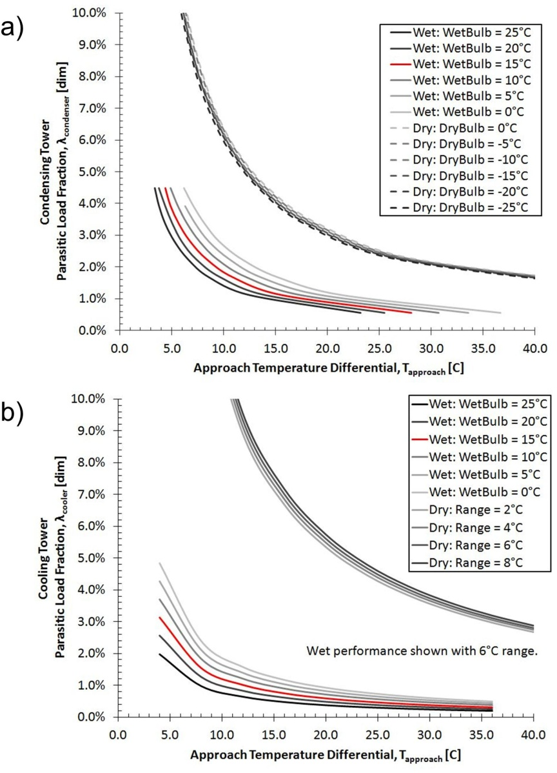

**Figure S1: Parasitic Load Fraction, λ, for a) Wet and Dry Condensing Towers and b) Wet and Dry Cooling Towers with respect to wet-bulb and dry-bulb temperature.** Using a wet tower substantially decreases the parasitic load. Dry tower load does not vary substantially with dry-bulb temperature (a), thus, cooling tower performance was characterized with respect to temperature range (b). The parasitic load fraction is proportional to the inverse approach temperature—doubling the approach temperature halves the parasitic load.

We regress the data for the curves in Figure S1 using Equation (S5) as the regression model. The resulting coefficients are shown in Table S1. Also shown are the overall standard error and uncertainty in calculating the parasitic load fraction, λ, which are found using the difference between the load fraction provided by BAC and the value calculated from Equation S5, using Equations S3-S4.

 (S5)

**Table S1: Coefficients for regression curves for the parasitic load fraction, λ, of cooling and condensing towers.**

|  |  |  |  |  |  |  |  |  |
| --- | --- | --- | --- | --- | --- | --- | --- | --- |
| Type | | a | b | c | d | e | SEλ | Uλ |
| cooling | wet | - 1.00 x10-4 | 1.91 x10-6 | 0.196 | - 0.00462 |  | ± 0.0007 | ± 0.00003 |
| cooling | dry |  |  | 1.044 |  | 0.0131 | ± 0.006 | ± 0.0009 |
| condensing | wet |  |  | 0.268 | - 0.0049 |  | ± 0.0009 | ± 0.0002 |
| condensing | dry |  |  | 0.619 |  |  | ± 0.002 | ± 0.0005 |

The performance of the wet tower depends on the ambient air temperature; the parasitic load fraction decreases as the ambient wet-bulb temperature increases. In contrast, the dry tower performance does not appear to vary substantially by dry-bulb temperature, so that we do not use it as a factor. The dry tower requires much more parasitic power than the wet tower. For example, at a 15°C ambient temperature and 10°C approach temperature, the wet tower parasitic load fractions are 1.3% (cooling) and 1.6% (condensing), whereas the dry tower parasitic load fractions are 9.2x (cooling) and 3.2x (condensing) higher. Ultimately, the selection of either a condensing tower or a cooling tower depends on the processes (cooling, condensing, or both) necessary to reduce the fluid to a saturated liquid state.

Due to the larger parasitic loads for dry cooling, wet tower technology is always preferred, even when the ambient temperature is below 0oC. The condensing temperature within a wet cooling tower may not be below the freezing point of water, otherwise ice will damage the unit. Therefore the condensing or cooling temperature of any liquid passing through a cooling or condensing wet tower is at least 7°C. At subzero ambient temperatures, we increase the approach temperature to maintain the outlet temperature at 7°C. Increasing the heat rejection temperature decreases the thermal efficiency of a system, but when the ambient temperature is below 0oC, the decrease in parasitic load fraction due to the increased approach temperature still results in higher power output than is attainable with a dry system.

**S3. Indirect System Operating Point Optimization**

When using R245fa as the secondary working fluid in an Organic Rankine Cycle, the power plant operator sets the boiling temperature by controlling the high-side pressure (States 9, 13, and 14 – see main paper). At high boiling temperatures, the thermal efficiency of the system is large, but the overall mass flowrate is small because of the pinch-point constraint. Similarly, at low boiling temperatures, the thermal efficiency of the Rankine cycle is low, but the mass flowrate is large. Therefore, an optimal boiling temperature for R245fa, for each inlet temperature into the Rankine cycle (State 6 – see main paper), exists, where power production is maximized. Figure S2 shows this optimal boiling temperature for each inlet CO2 or brine temperature. The discontinuity around 180°C inlet temperature for R245fa is due to the non-linear shifting ratio of boiling to preheating thermal energy as boiling temperature increases and approaches the critical temperature, Tcrit,R245fa = 154 °C.

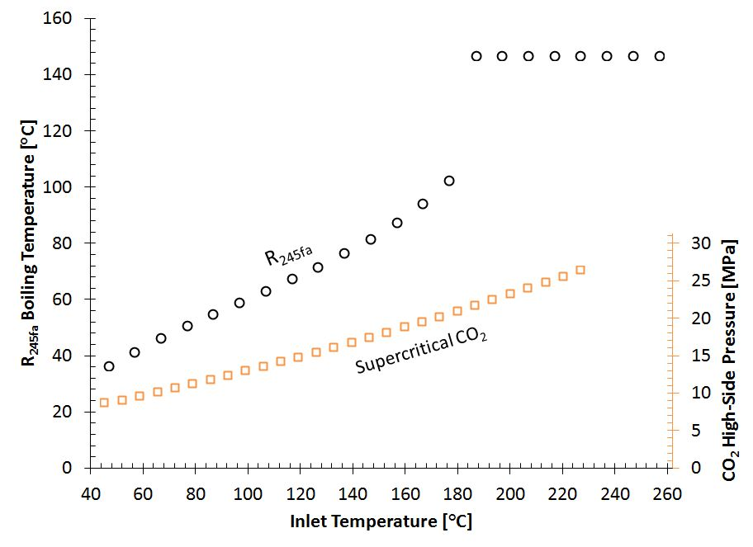

Figure S2: Secondary Rankine Cycle Operating Points. The high-side temperature or pressure of the secondary Rankine cycle is used which will produce the most power, based on its working fluid.

Similarly, the power plant operator sets the high-side pressure of the supercritical CO2 Rankine indirect system. If the pressure is too high, the pump outlet temperature becomes high, and the energy input into the system decreases, decreasing power. If the pressure is too low, the pressure differential across the turbine is small, and power decreases. Therefore, an optimal secondary CO2 pressure exists for all primary inlet CO2 or brine temperatures (State 6 – see main paper), shown on the secondary axis in Figure S2. The secondary working fluid CO2 system does not operate near the critical point resulting in a relatively linear curve.

We perform a linear regression for each of the roughly linear regions in Figure S2. For supercritical CO2, the optimal high-side pressure is predicted by:

*P*CO2(MPa) = 0.096 * *T*inlet(°C) + 3.78, (S6)

with an *R*2 value of 0.995. Similarly, for brine with an inlet temperature below 180°C, the optimal boiling temperature is predicted by:

*T*R245fa(°C) = 0.48 * *T*inlet(°C) + 13.1, (S7)

with an *R*2 value of 0.991, whereas for inlet temperatures above 180°C, the optimal boiling temperature is constant at 147°C.

**S4 Assumptions and Reduction of Parameters**

Given the large number of variables, the fluid mass flowrate, approach temperature, and cooling tower technology are examined in the following sections and then fixed for the simulations in the main paper. To note, using the average annual temperature results in conservative estimates of the average annual power production.

**S4.1 Optimal Fluid Mass Flowrate**

The fluid mass flowrate is set in different ways for each type of system. In pumped systems, the mass flowrate is set by regulating the pumping power applied, and thus pressure differential induced, by the pumps. In thermosiphon-driven systems, the mass flowrate is set by regulating the outlet pressure of the turbine or by adjusting the pressure drop through the pre-injection throttle valve. Figure S3 shows the power curves for the base case, un-pumped, direct system. Analogous power curves exist for each combination of well diameter, geothermal temperature gradient, reservoir depth and permeability, and surface plant design. For each combination, there is a mass flowrate where system inefficiencies and throughput are in balance, and the net power output is maximized.

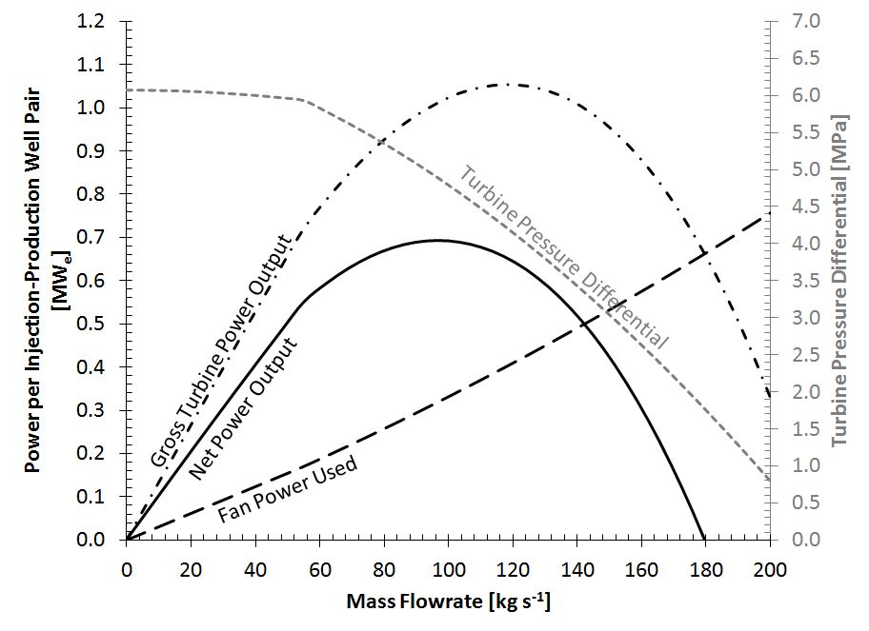

Figure S3 (Also Figure 4 in main text): Example of Net Power Output of an Un-pumped Direct CO2 System for One Injection-Production Well Pair as a function of Fluid Mass Flowrate. [Base-case] At low fluid mass flowrates, turbine power output is small, despite high thermodynamic cycle efficiencies. At high mass flowrates, turbine output drops due to decreasing pressure differential caused by increased system pressure losses. This interaction results in a net power curve with a maximum value (here ~100 kg s-1). This mass flowrate is unique and must be found for every scenario.

Figure S3 illustrates the tradeoff between net power production and losses in the unpumped direct CO2 Plume Geothermal (CPG) system base-case for one injection-production well pair. At low mass flowrates, the system thermodynamic efficiency is high due to the small amount of irreversibilities (pressure losses – minor temperature losses are not accounted for due to the adiabatic assumption), but the net power generated is also small due to low fluid mass flowrates. As mass flowrate increases, the pressure losses increase by the square of the mass flowrate (Equation 6) and less pressure is available to drive the turbine. As a result, the net power output goes to zero at high mass flowrates. In this example, the net power reaches zero when the mass flowrate reaches 180 kg s-1, where the gross turbine output equals the parasitic fan load.

Thus, the mass flowrate that provides the largest net power output for each scenario is used.

**S4.2 Approach Temperature**

In the direct system and on the secondary side of the indirect system, the approach temperature is set by selecting the outlet pressure of the turbine, thereby selecting the condensing temperature. To demonstrate the strong influence of approach temperature, the net power output is shown in Figure S4 for approach temperatures ranging from 4 °C to 30 °C for the direct, pumped base-case scenario.

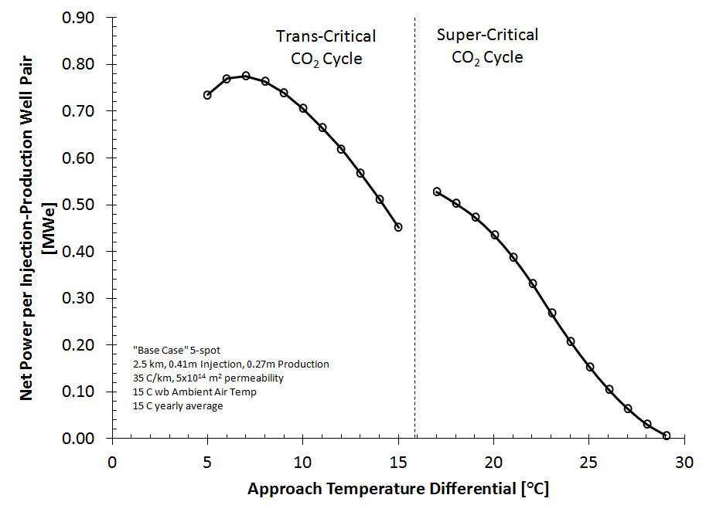

Figure S4: Net Power Output for the Base Case. Increasing the approach temperature increases the injection temperature of the geothermal fluid and decreases turbine power output, whereas decreasing the approach temperature decreases the parasitic condensing/cooling tower load. This results in an optimal net power output near 7 °C which is used in all other scenarios.

At low approach temperatures, the system thermodynamic efficiency is higher than at large approach temperatures because the heat rejection temperature is low, however, the parasitic condensing and cooling loads are also high. As the approach temperature increases, the parasitic load drops faster than the system efficiency. The optimal approach temperature, yielding maximum net power output, exists near 7°C, which is used hereafter.

The net power increases when the approach temperature increases from 15°C to 17°C due to the substantial decrease in pumping power needed in the super-critical cycle. In the trans-critical cycle, the pressure at the turbine exit (Figure 3, State 5 – see main paper) is fixed by the condensation temperature (Figure 3, State 6 – see main paper); however, in the super-critical cycle, the pressure and temperature can vary independently. The result is a larger turbine exit pressure while maintaining the same approach temperature, but reducing pumping power by 90%. This thermodynamic trade-off only occurs near the critical point of CO2 (approach temperature = 16°C), and overall net power is still maximized using the trans-critical cycle with an approach temperature of 7°C.

**S4.3 Average Annual Power Production**

The average annual wet-bulb temperature for a site can be used to approximate the average annual power production. The direct, pumped CO2 system is simulated for the base-case at two sites over the course of a ‘normal’ year, averaged, and then compared with a single simulation using only the average wet-bulb temperature. Power production values are simulated for Dallas, Texas (TX), and Williston, North Dakota (ND), which have average wet-bulb temperatures of 14.3°C and 2.5°C, respectively. These two cities are at different latitudes within the continental United States and can thus represent the expected extremes in ambient conditions. The monthly wet-bulb temperature values are obtained from the Climate Normals, provided by the National Climactic Data Center (NCDC, 2013).

Our simulated average power production over the year for Dallas is 0.90 MWe per injection-production well pair in the inverted 5-spot well pattern, using the monthly average wet bulb temperature, compared with 0.81 MWe, a decrease of 11%, when the annual average value is used. Similarly, the average power production per injection-production well pair in Williston is 1.41 MWe using monthly values, and decreases only 0.7% to 1.40 MWe when the annual average wet-bulb temperature is used. The inverted 5-spot well pattern contains 4 injection-production pairs, thus, the injection-production power must be multiplied by 4 to obtain the power production for one inverted 5-spot well system (Figure 1 – see main paper). Thus, the inverted 5-spot well systems are expected to generate an average of approximately 3.2 MWe and 5.6 MWe in Dallas and Williston, respectively. Typically, multiple such 5-spot systems would be combined in one overall geothermal power plant system.

Williston, ND, exhibits the small difference in monthly versus yearly-averaged power production because of the extremely cold winter conditions. When the ambient temperature drops below 0oC, the condensing temperature of the tower must stay above 0oC. The thermal efficiency of most systems increases with decreasing wet-bulb temperatures, but sub-zero weather mitigates this effect and results in a linear relationship between temperature and power production. Warmer climates, like Dallas, TX, have larger changes in thermal efficiency throughout the year, and tend to produce on average more power than the average annual temperature would predict. Therefore, the average annual temperature is typically a conservative estimate of average annual power production with an estimated uncertainty of 11%.

**S5. Net Electric Output Power Tables**

The net electric power produced for all six surface plant types are shown in Figure S5, where each value represents a single injection-production pair. The values must be multiplied by four to obtain the total power production for the entire inverted 5-spot well system. Each of the surface plant tables displays 225 values of the 945 calculated. The parameters which are not displayed are: one permeability of 5 x10-15 m2 and six combinations of injection (Inj) and production (Prod) well inner diameter pairs: (0.41m Inj / 0.33m Prod), (0.41m Inj / 0.27m Prod), (0.33m Inj / 0.27m Prod), (0.33m Inj / 0.14m Prod), (0.27m Inj / 0.14m Prod), and (0.14m Inj / 0.14m Prod).

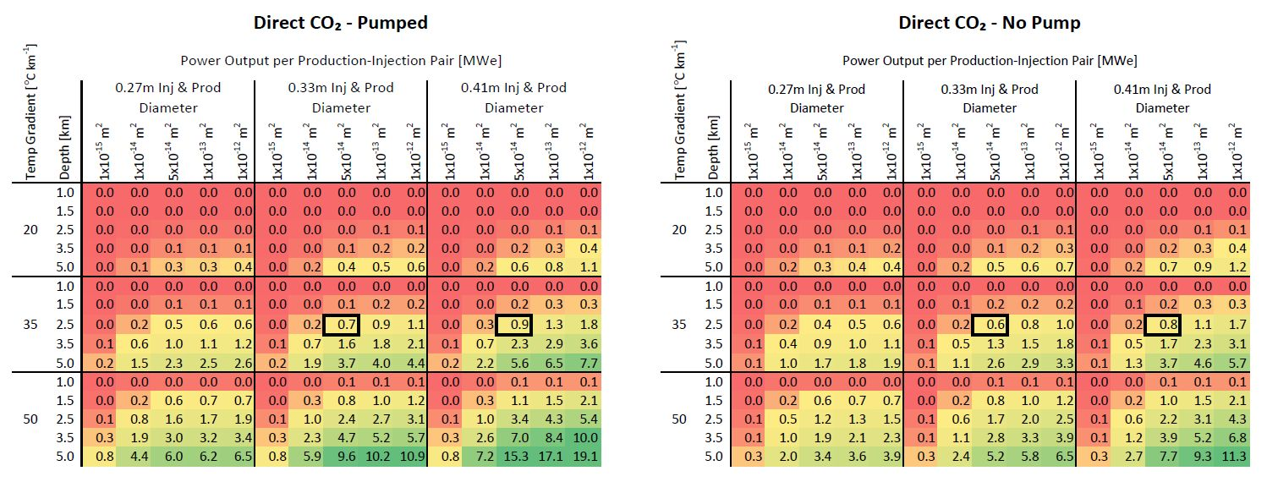

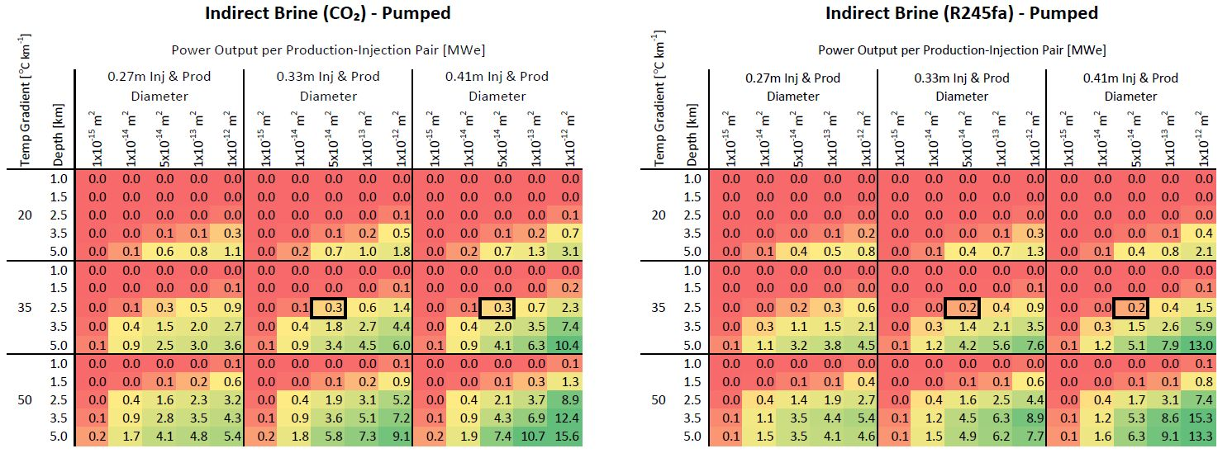

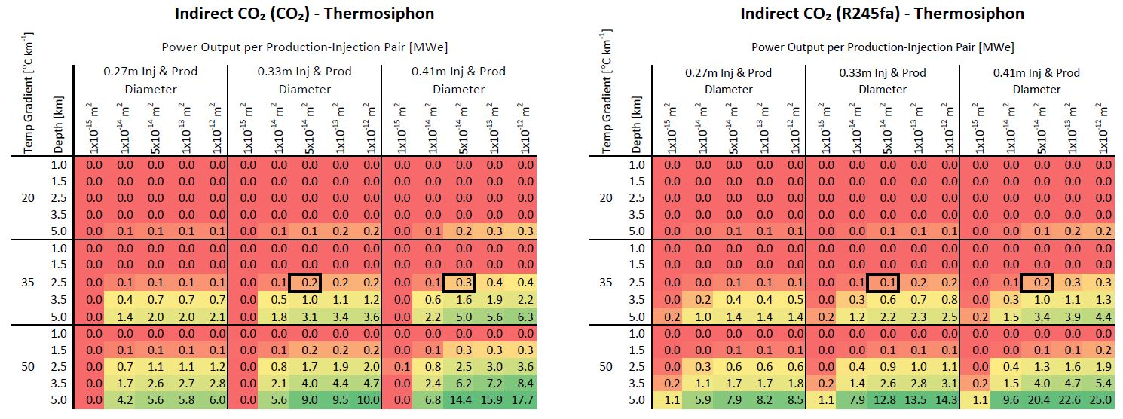

Figure S5: Net Electric Power Production per Injection-Production Well Pair for all Six Surface Plant Configurations. These plots show all six surface plant configurations, unlike Figure 5 I the main paper, which only displays values for the Direct CO2-Pumped and the Indirect (always pumped) Brine (with R245fa as secondary working fluid) system. The net power values are color coded to show low (red), moderate (yellow), and substantial (green) electrical production. The values shown are for a single injection-production pair and must be multiplied by four to obtain the value for the entire inverted 5-spot. The two boxed values in each plot bound the base-case (0.41m injection and 0.27m production well inner diamters).

**S6. Electric Power and Mass Flowrate Data**

The calculated electric power and mass flowrate values are attached to this supplemental information in the form of an EXCEL (*.xlsx) file. The information can be filtered by any of the input parameters. Column labels correspond the Figures 3 or 4 in the main paper. A value of zero in either the Net Power or Mass Flowrate column indicates that either the model was not able to solve for the given set of parameters, or the model did solve it but did not yield a positive net power for any mass flowrate.

**S7. Nomenclature**

Nomenclature for this supplemental information is provided in Table S2.

|  |  |
| --- | --- |
| **Table S2: Nomenclature.** | |
| *a…e* | Fit coefficients |
| *N* | Number of samples [-] |
| *PCO2* | Pressure of CO2 [kPa] |
| *Pcooler* | Power required for Cooler [kWe] |
| *Pcondenser* | Power required for Condenser [kWe] |
| *Q* | Heat Energy Transfer Rate [kWth] |
| *S* | Average Specific Kinematic Viscosity [m s-1] |
| *SES* | Standard Error in prediction of *S* [m s-1] |
| *t* | Student’s-t Value [-] |
| *T* | Temperature [°C] |
| *Tapp* | Approach Temperature Differential [°C] |
| *Tr* | Tower Range [°C] |
| *Twb* | Ambient Wet Bulb Temperature [°C] |
| *US* | Uncertainty in regression of S [m s-1] |
| *λ* | Parasitic Loss Fraction [kWe kWth-1] |
|  | |

**S8. References**

Baltimore AirCoil (BAC). (2013). Baltimore AirCoil’s product selection software. Retrieved from http://www.baltimoreaircoil.com/english/product-selection-software-public.

Class, H., et al. (2009). A benchmark study on problems related to CO2 storage in geologic formations: Summary and discussion of the results. *Computational Geosciences*, 13, 409-434.

National Climactic Data Center (NCDC). (2013). The national climactic data center monthly normals. Retrieved from http://www.ncdc.noaa.gov/cdo-web/.